Wt – Assigment

Anusthan Singh (20051337)

Q1.

Code:-

<!DOCTYPE *html*>

<html *lang*="en">

<head>

    <meta *charset*="UTF-8">

    <meta *http-equiv*="X-UA-Compatible" *content*="IE=edge">

    <meta *name*="viewport" *content*="width=device-width, initial-scale=1.0">

    <title>Webpage</title>

    <script>

        function myFunction() {

          alert("Data saved sucessfully!");

        }

        </script>

</head>

<body>

    <form *action*="insert.php" *method*="POST">

    <p>FNAME <input *type*="text" *id*="fanme" *name*="fname"></p>

    <br>

    <p>LNAME <input *type*="text" *id*="lanme" *name*="lname"></p>

    <br>

    <p>ROLLNO <input *type*="number" *id*="ROLLNO" *name*="ROLLNO"></p>

    <br>

    <p>

        <label> Branch </label>

        <select *name*="course" *id*="course">

            <option *value*="Cse">Cse</option>

            <option *value*="IT">IT</option>

            <option *value*="CSSE">CSSE</option>

            <option *value*="CSCE">CSCE</option>

        </select>

    </p>

    <br>

<div *style*="border: solid 1px;">

     <p *name*="gender" *id*="gender" ><legend> Gender </legend>

        <input *type*="radio" *name*="gender" *value*="male">male

        <input *type*="radio" *name*="gender" *value*="female">female

    </p>

</div>

<br>

<p>

    <label> Qualification </label>

    <select *name*="qualification" *id*="qualification" >

        <option *value*="B.tech">B.tech</option>

        <option *value*="MCA">MCA</option>

        <option *value*="M.tech">M.tech</option>

        <option *value*="baap ke cash pe aish">BCA</option>

    </select>

</p>

<input *type*="submit" *value*="Submit" *name*="submit">

</form>

</body>

</html>

Backend code

<?php

if (isset($_POST['submit'])) {

    if (isset($_POST['fname'])  && isset($_POST['lname']) && isset($_POST['ROLLNO']) &&

        isset($_POST['course']) && isset($_POST['gender']) &&

        isset($_POST['qualification']) ) {

        $fname = $_POST['fname'];

        $lname = $_POST['lname'];

        $ROLLNO = $_POST['ROLLNO'];

        $course = $_POST['course'];

        $gender = $_POST['gender'];

        $qualification = $_POST['qualification'];

        $host = "localhost";

        $dbfname = "root";

        $dblname = "";

        $dbName = "test";

        $conn = new mysqli($host, $dbfname, $dblname, $dbName);

        if ($conn->connect_error) {

            die('Could not connect to the database.');

        }

        else {

            $Select = "SELECT qualification FROM assig WHERE qualification = ? LIMIT 1";

            $Insert = "INSERT INTO assig(fname, lname, ROLLNO, course, gender, qualification) values(?, ?, ?, ?, ?, ?)";

            $stmt = $conn->prepare($Select);

            $stmt->bind_param("s", $qualification);

            $stmt->execute();

            $stmt->bind_result($resultqualification);

            $stmt->store_result();

            $stmt->fetch();

            $rnum = $stmt->num_rows;

            if ($rnum == 0) {

                $stmt->close();

                $stmt = $conn->prepare($Insert);

                $stmt->bind_param("ssssii",$fname, $lname, $ROLLNO, $course ,$gender, $qualification);

                if ($stmt->execute()) {

                    echo "New record inserted sucessfully.";

                }

                else {

                    echo $stmt->error;

                }

            }

            else {

                echo "Someone already assigs using this qualification.";

            }

            $stmt->close();

            $conn->close();

        }

    }

    else {

        echo "All field are required.";

        die();

    }

}

else {

    echo "Submit button is not set";

}

?>

Output:-

Table Structure

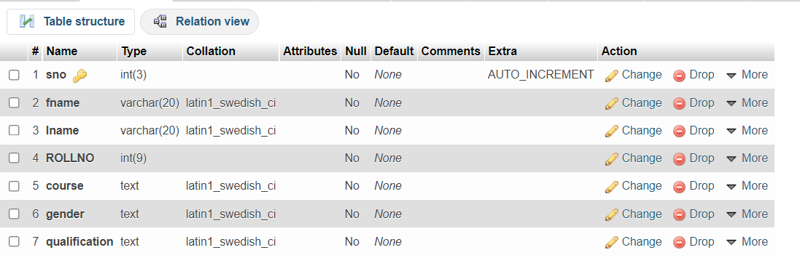

Website:;-

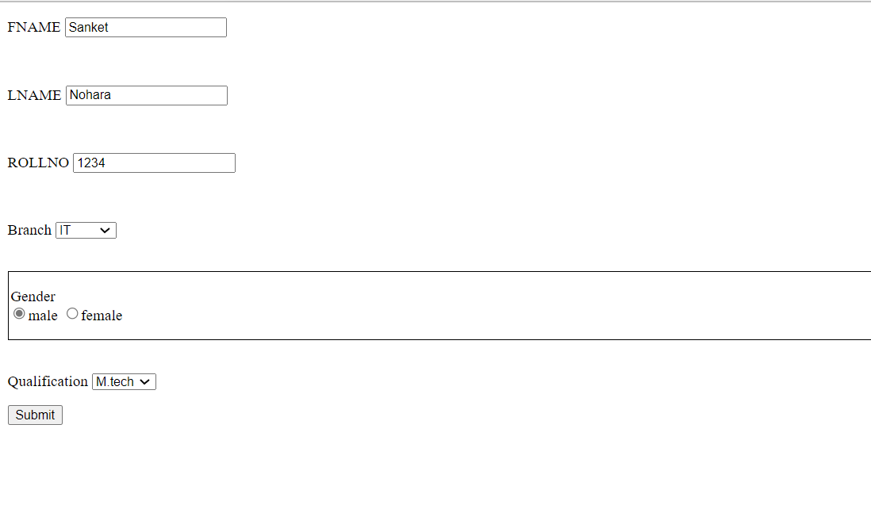

Output:-



Before:-



(AS U CAN SEE IT EMPTY)

After:-

